**OFF LAB**

***Part 3***

%%%%%%%% Part 3 %%%%%%%%%%%

x = [1 0 2;-1 3 1;-2 4 0];

h = [1 -1;0 2];

y = DSLSI2D(h,x);

y

function[y]=DSLSI2D(h,x)

sizeOfX = size(x);

My = sizeOfX(1);

Mx = sizeOfX(2);

sizeOfH = size(h);

Hy = sizeOfH(1);

Hx = sizeOfH(2);

y = zeros(My+Hy-1,Mx+Hx-1);% output length = input length + response length - 1

for k = 0:Hy-1

for l = 0:Hx-1

y(k+1:k+My,l+1:l+Mx) = y(k+1:k+My,l+1:l+Mx) + h(k+1,l+1)*x;

end

end

end

***Part 4***

%%%%%%%%% Part 4 %%%%%%%%%%

originalImage=ReadMyImage("Part4.jpg");

figure(1)

subplot(2,2,1);

imshow(originalImage,[]);

title("Original");

D6 = mod(21501462,6); %%%This is zero

%%% I need to pick Hy = Hx = 3 for second task

%%% According to instructions

%%%%%%%%% Different Hx and Hy values %%%%%%%%%%%%%%%

Hy = 3;

Hx = 3;

B = 6*pi/10; %% Second last digit is 6

denoisedImage1 = denoiser(originalImage,Hy,Hx,B);

subplot(2,2,2);

imshow(denoisedImage1,[]);

title("Hx = Hy = " + Hx);

Hy = 4;

Hx = 4;

denoisedImage2 = denoiser(originalImage,Hy,Hx,B);

subplot(2,2,3);

imshow(denoisedImage2,[]);

title("Hx = Hy = " + Hx);

Hy = 6;

Hx = 6;

denoisedImage3 = denoiser(originalImage,Hy,Hx,B);

subplot(2,2,4);

imshow(denoisedImage3,[]);

title("Hx = Hy = " + Hx);

%%%%%%%%%%%%%%%%%%%%%%%%%%%%%%%%%%%%%%%%%%%%%%%%%%%%%%%%%%%

%%%%%%%%%%%%%%%Different B values%%%%%%%%%%%%%%%

figure(2)

subplot(2,2,1);

imshow(originalImage,[]);

title("Original");

Hy = 4;

Hx = 4;

B = 0.9;

denoisedImage4 = denoiser(originalImage,Hy,Hx,B);

subplot(2,2,2);

imshow(denoisedImage4,[]);

title("B = " + B);

Hy = 4;

Hx = 4;

B = 0.6;

denoisedImage5 = denoiser(originalImage,Hy,Hx,B);

subplot(2,2,3);

imshow(denoisedImage5,[]);

title("B = " + B);

Hy = 4;

Hx = 4;

B = 0.3;

denoisedImage6 = denoiser(originalImage,Hy,Hx,B);

subplot(2,2,4);

imshow(denoisedImage6,[]);

title("B = " + B);

%%%%%%%%%%%%%%%%%%%%%%%%%%%%%%%%%%%%%%%%%%%%%%%%%

%%%%%%%%%%% Best Case Scenerio (According to me) %%%%%%%%%%%%%%%%

figure(3)

subplot(2,1,1);

imshow(originalImage,[]);

title("Original");

Hy = 4;

Hx = 4;

B = 0.3;

denoisedImage7 = denoiser(originalImage,Hy,Hx,B);

subplot(2,1,2);

imshow(denoisedImage7,[]);

title("Best Looking one -> "+"B = " + B + " Hy = Hx = " + Hy);

function[y]=denoiser(image,Hy,Hx,B)

h = zeros(Hy,Hx);

for m = 1:Hy

for n = 1:Hx

h(m,n) = (B/pi).*sinc((B*(m-(Hy-1)/2))./pi).*(B/pi).*sinc((B*(n-(Hx-1)/2))./pi);

end

end

y = DSLSI2D(h,image);

end

function[y]=DSLSI2D(h,x)

sizeOfX = size(x);

My = sizeOfX(1);

Mx = sizeOfX(2);

sizeOfH = size(h);

Hy = sizeOfH(1);

Hx = sizeOfH(2);

y = zeros(My+Hy-1,Mx+Hx-1);% output length = input length + response length - 1

for k = 0:Hy-1

for l = 0:Hx-1

y(k+1:k+My,l+1:l+Mx) = y(k+1:k+My,l+1:l+Mx) + h(k+1,l+1)*x;

end

end

end

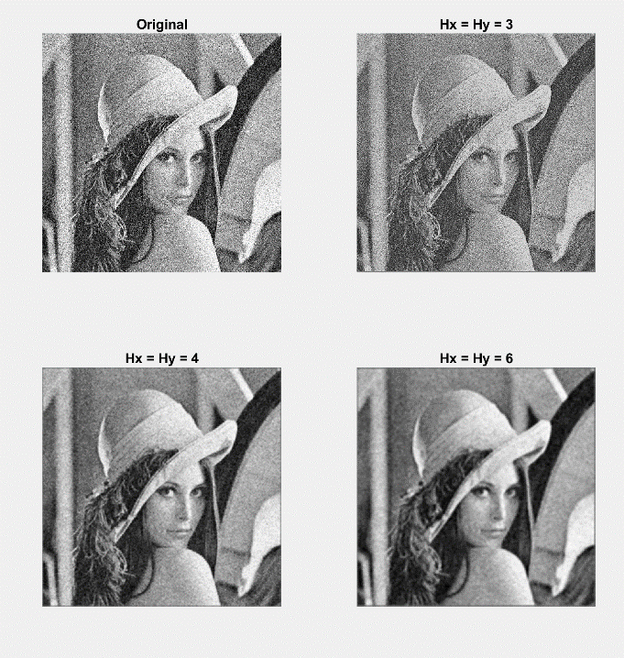 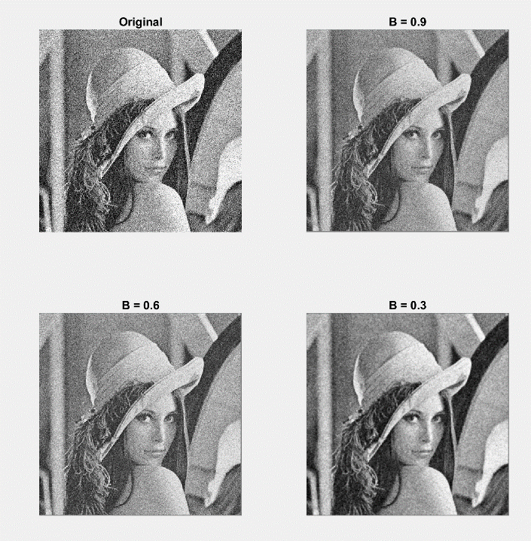

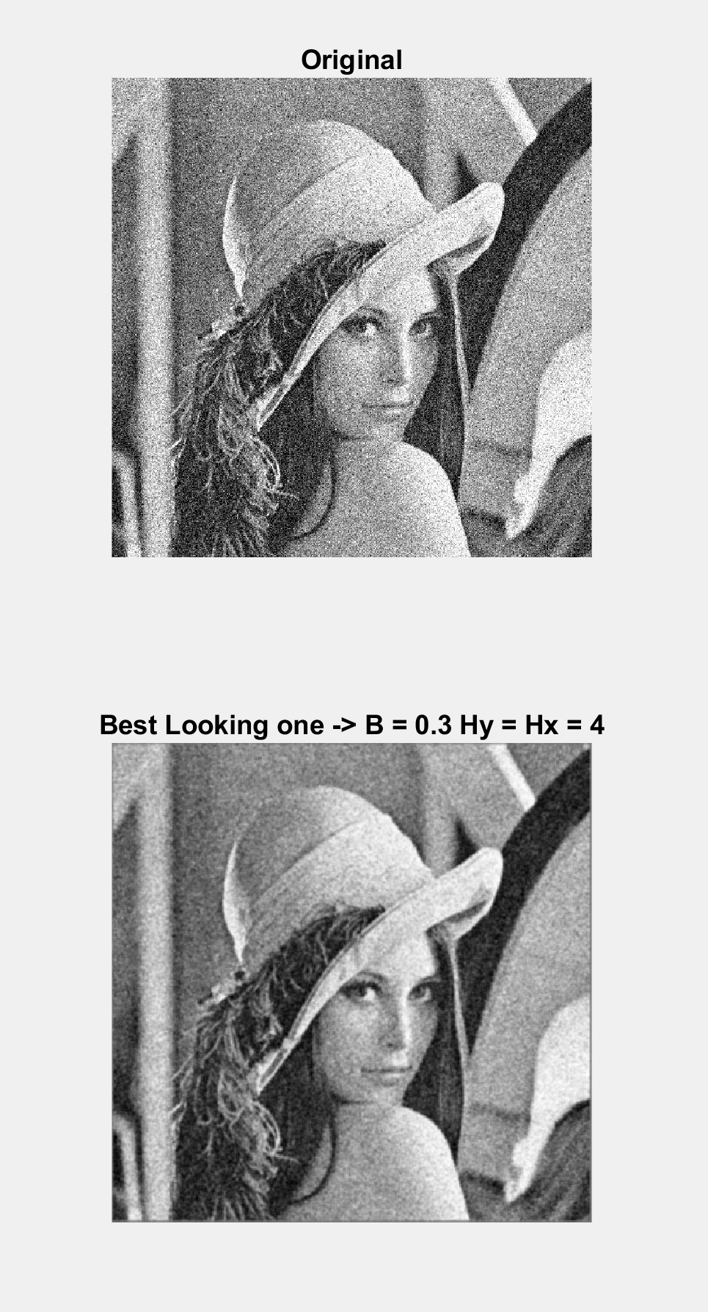

***Part 5***

%%%%%%%%%%%%%Part 5 %%%%%%%%%%%%

originalImage=ReadMyImage("Part5.bmp");

figure(1)

imshow(originalImage,[]);

title("Original");

h1 = [1 0 -1;1 0 -1;1 0 -1];

h2 = [1 1 1;0 0 0;-1 -1 -1];

y1 = DSLSI2D(h1,originalImage);

s1 = y1.^2;

y2 = DSLSI2D(h2,originalImage);

s2 = y2.^2;

figure(2)

subplot(2,2,1);

imshow(y1,[]);

title("y1[m,n]");

subplot(2,2,2);

imshow(s1,[]);

title("s1[m,n]");

subplot(2,2,3);

imshow(y2,[]);

title("y2[m,n]");

subplot(2,2,4);

imshow(s2,[]);

title("s2[m,n]");

function[y]=DSLSI2D(h,x)

sizeOfX = size(x);

My = sizeOfX(1);

Mx = sizeOfX(2);

sizeOfH = size(h);

Hy = sizeOfH(1);

Hx = sizeOfH(2);

y = zeros(My+Hy-1,Mx+Hx-1);% output length = input length + response length - 1

for k = 0:Hy-1

for l = 0:Hx-1

y(k+1:k+My,l+1:l+Mx) = y(k+1:k+My,l+1:l+Mx) + h(k+1,l+1)*x;

end

end

end

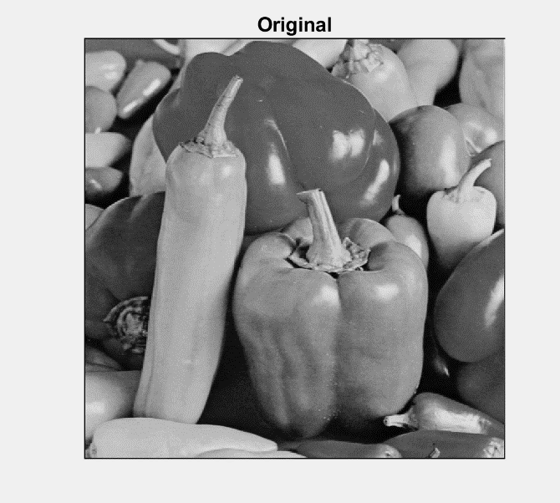

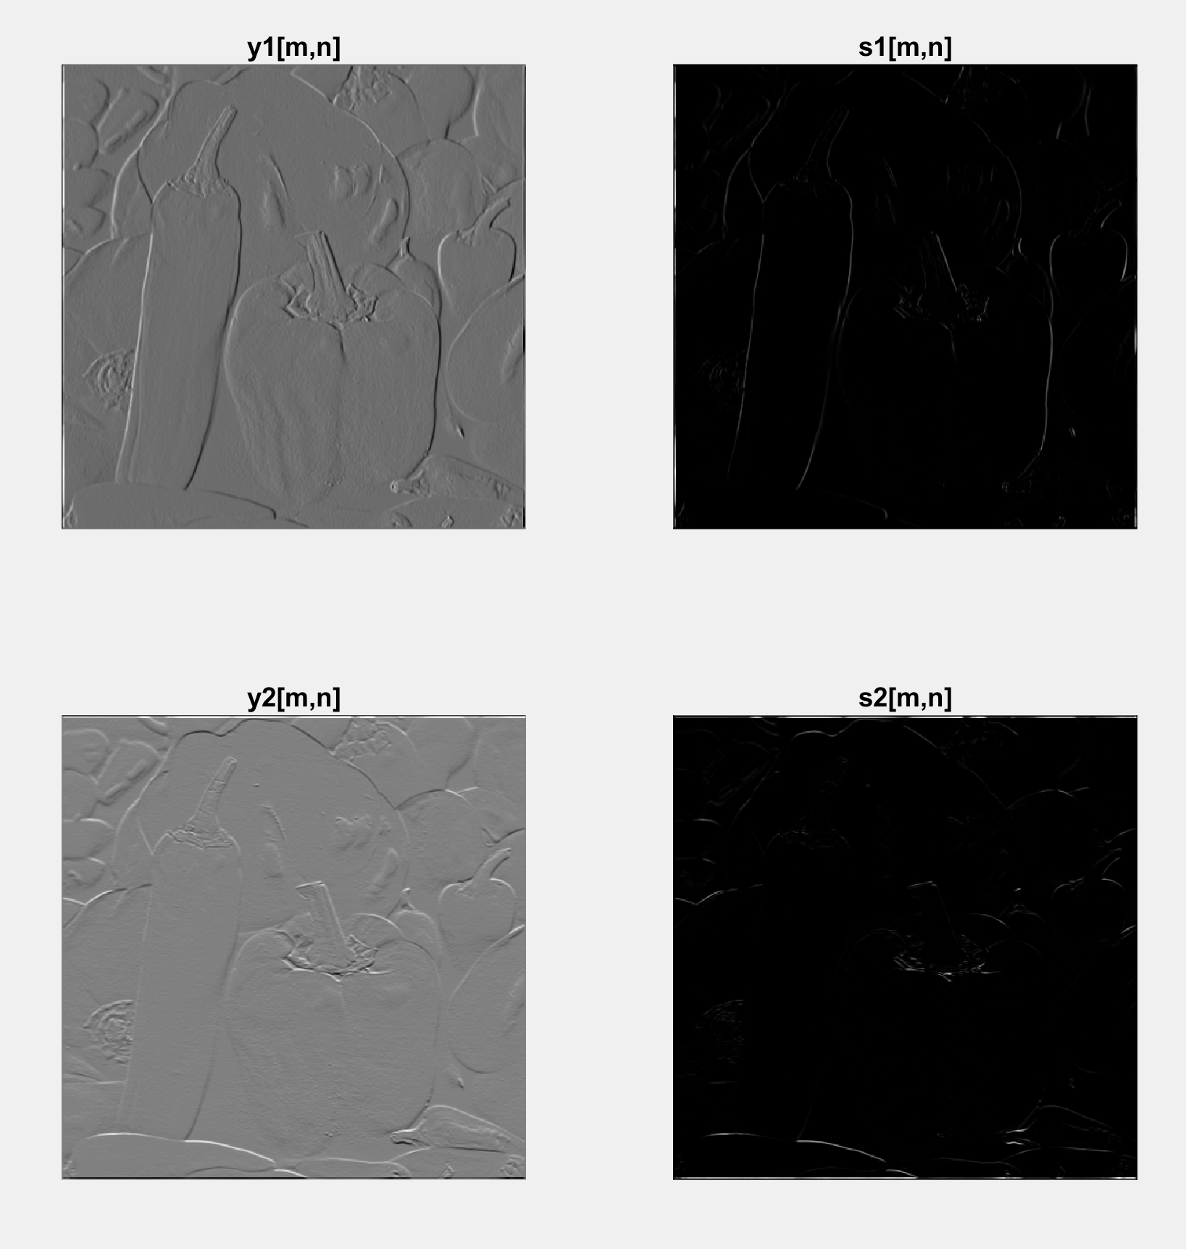

**ON LAB**

***Part 1,2,3***

image=ReadMyImage("Part1.bmp");

subplot(1,2,1);

imshow(image,[]);

title("Image");

h1 = [0 -1 -1;1 0 -1;1 1 0];

y1 = DSLSI2D(h1,image);

subplot(1,2,2);

imshow(y1,[]);

title("Diagonal edges");

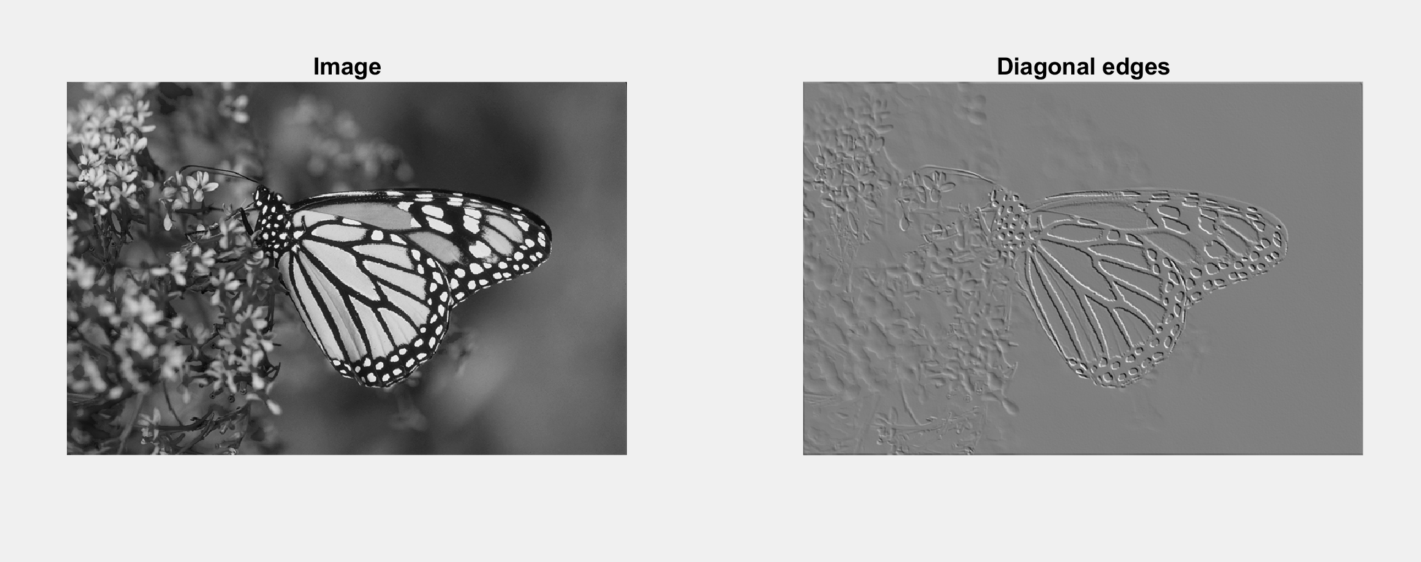

***Part 4***

function[y,My2,Ny2]=DSLSI2D_onlab(h,Mh2,Nh2,x,Mx2,Nx2)

sizeOfX = size(x);M

Mx = sizeOfX(1);

Nx = sizeOfX(2);

sizeOfH = size(h);

Mh = sizeOfH(1);

Nh = sizeOfH(2);

y = zeros(Mx+Mh-1,Nx+Nh-1);% output length = input length + response length - 1

My2 = Mx2+Mh2;

Ny2 = Nx2+Nh2;

for k = 0:Mh-1

for l = 0:Nh-1

y(k+1:k+Mx,l+1:l+Nx) = y(k+1:k+Mx,l+1:l+Nx) + h(k+1,l+1)*x;

end

end

end